**Manifiesto**

<?xml version="1.0" encoding="utf-8"?>

<manifest xmlns:android="http://schemas.android.com/apk/res/android"

xmlns:tools="http://schemas.android.com/tools">

<application

android:allowBackup="true"

android:dataExtractionRules="@xml/data_extraction_rules"

android:fullBackupContent="@xml/backup_rules"

android:icon="@mipmap/ic_launcher"

android:label="@string/app_name"

android:roundIcon="@mipmap/ic_launcher_round"

android:supportsRtl="true"

android:theme="@style/Theme.AppPractica1"

tools:targetApi="31">

<activity

android:name=".MainActivity"

android:exported="true"

android:label="@string/app_name"

android:theme="@style/Theme.AppPractica1">

<intent-filter>

<action android:name="android.intent.action.MAIN" />

<category android:name="android.intent.category.LAUNCHER" />

</intent-filter>

</activity>

</application>

</manifest>

**MainActivity**

package com.curso.android.app.practica.uno

import android.os.Bundle

import com.google.android.material.snackbar.Snackbar

import androidx.appcompat.app.AppCompatActivity

import androidx.navigation.findNavController

import androidx.navigation.ui.AppBarConfiguration

import androidx.navigation.ui.navigateUp

import androidx.navigation.ui.setupActionBarWithNavController

import android.view.Menu

import android.view.MenuItem

import com.curso.android.app.practica.uno.databinding.ActivityMainBinding

class MainActivity : AppCompatActivity() {

private lateinit var appBarConfiguration: AppBarConfiguration

private lateinit var binding: ActivityMainBinding

override fun onCreate(savedInstanceState: Bundle?) {

super.onCreate(savedInstanceState)

binding = ActivityMainBinding.inflate(*layoutInflater*)

setContentView(binding.*root*)

setSupportActionBar(binding.toolbar)

val navController = *findNavController*(R.id.*nav_host_fragment_content_main*)

appBarConfiguration = *AppBarConfiguration*(navController.graph)

*setupActionBarWithNavController*(navController, appBarConfiguration)

binding.fab.setOnClickListener **{** view **->**

Snackbar.make(view, "Replace with your own action", Snackbar.*LENGTH_LONG*)

.setAction("Action", null).show()

**}**

}

override fun onCreateOptionsMenu(menu: Menu): Boolean {

// Inflate the menu; this adds items to the action bar if it is present.

*menuInflater*.inflate(R.menu.*menu_main*, menu)

return true

}

override fun onOptionsItemSelected(item: MenuItem): Boolean {

// Handle action bar item clicks here. The action bar will

// automatically handle clicks on the Home/Up button, so long

// as you specify a parent activity in AndroidManifest.xml.

return when (item.*itemId*) {

R.id.*action_settings* -> true

else -> super.onOptionsItemSelected(item)

}

}

override fun onSupportNavigateUp(): Boolean {

val navController = *findNavController*(R.id.*nav_host_fragment_content_main*)

return navController.*navigateUp*(appBarConfiguration)

|| super.onSupportNavigateUp()

}

}

Tablet

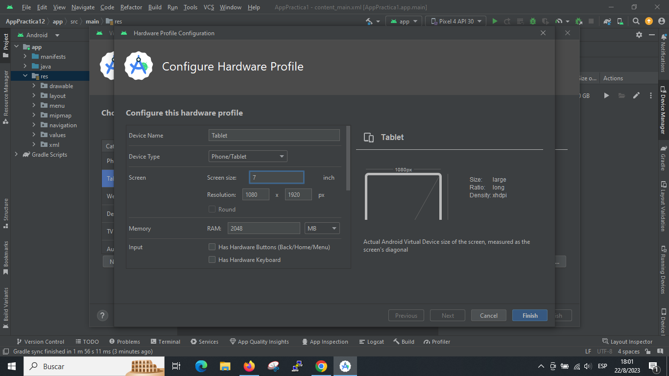

Telefono

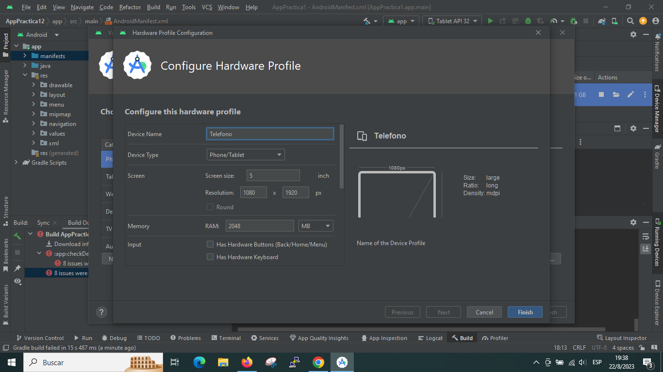

**Actividad 4**

En la tablet la información se ve a un lado y en el teléfono por ser la pantalla más chica se ve aparte.